Paper No. XXXX

Each Major Word of the Title Should be Capitalised, Using
14 Point Times New Roman Bold Font

First author^{1,*}, Second author², Third author³

¹ Affiliation of first author, Address
² Affiliation of second author, Address
³ Affiliation of third author, Address

* Corresponding author’s email:

INTRODUCTION
Please read carefully all the instructions given below and follow the instructions exactly when you prepare your manuscript to ensure uniformity in the appearance of the papers in the conference proceedings. The provided template follows the required format and it is strongly recommended to use it as a starting point for your paper. The complete manuscript (full text and figures) should be submitted as a PDF file.
Contributions are accepted on the understanding that the paper is original and has not been published before.
Please note that you can only submit your paper after you have been notified of abstract approval. The conference proceedings will be published on the website (www.npc2025.org) in PDF files. For the Draft Papers, the author(s) only have to electronically submit their PDF file via the Website for review (due date: June 30, 2025). Authors who want to get more information can contact us via email at paper@npc2025.org.

LANGUAGE
All papers must be written in English, without grammatical or spelling errors.

PAPER LENGTH
The suggested length of your paper is 4-12 pages unless otherwise indicated in your acceptance letter. This number includes title, abstract, text, figures, tables, references and appendices.

PAGE LAYOUT
With A4 paper, use a text area of 16.5 x 23 cm with margins of 2.5 cm from top and left edge.

HEADER AND FOOTER
Please use the headers provided in this template. Include the assigned paper number in the header of pages. For more information about the numbers, visit www.npc2025.org. The footer should be left blank.

ABSTRACT
An abstract should follow the author information on the first page. The word “ABSTRACT” is followed by the abstract text which contains up to a maximum of 250 words. This should be the same abstract that was submitted for consideration. Keywords should follow the abstract as below.
Keywords: keyword 1, keyword 2, keyword 3 (no more than 5 keywords)

PARAGRAPH AND FONT
All papers must use 11 point Times New Roman with using single line spacing, except use 14 point Times New Roman for the title of the paper as shown in this template. All paragraphs should be single column and justified.
Paragraphs should not be indented, and each paragraph is followed by 6 pt spacing.

PRIMARY HEADINGS
All headings should be positioned flush left. Headings should be presented as shown in this template, where primary headings are written in upper case bold with 12 point spacing above and below the heading. Primary headings can be generated using the Heading 1 style in this template.

Secondary Headings
Secondary Headings should be written in italic bold font, and the first characters of all words in a secondary heading should be written in upper case with 6 point spacing above and below the heading. Secondary headings can be generated using the Heading 2 style in this template.

FIGURES, TABLES AND EQUATIONS
Centre table title above the table and figure caption below the figure. Allow one line of space between the table, table title, figure or figure caption and the adjacent text. Tables and figures may be in colour.
Figures, equations and tables should be included in the text and numbered sequentially. For example:

Table 1. Tables should be centred and preceded by a numbered caption
Variables | Means | SD | Min | Max | %Missing values
Load ratio, R | 0.4 | 0.3 | 0.1 | 0.95 | 0
Chrome content, Cr (wt%) | 17.1 | 0.91 | 16.3 | 18.7 | 11
Carbon content, C (wt%) | 0.03 | 0.011 | 0.01 | 0.05 | 12

Allow one line of space between the table, table title, figure or figure caption and the adjacent text.

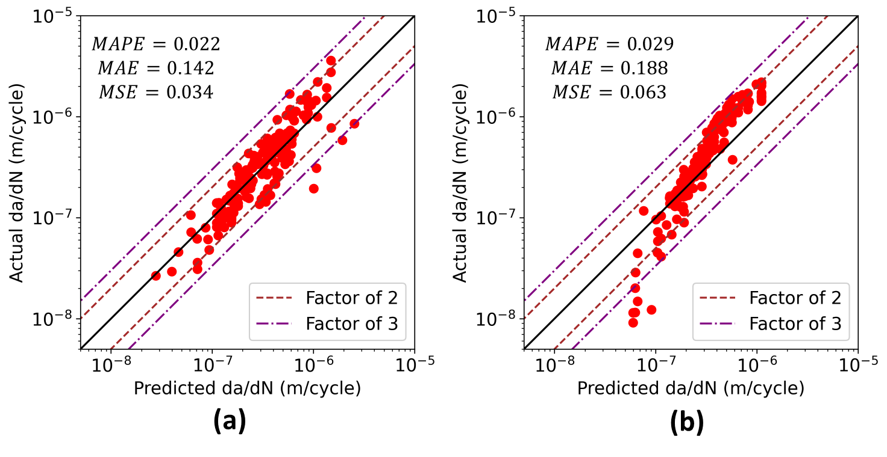
Figure 1. Figures should be centred and followed by a numbered caption.

Equations should be centred and numbered in parentheses. The equation number should be positioned flush right. Equations should be referred to in the text as in the following example. See Equation 1 below:
(1)

CONCLUSION
References should be written using single-spaced 11 point Times New Roman font and should be listed in the order in which they are mentioned in the manuscript. The reference number should be mentioned at the end of the cited sentence [1].

ACKNOWLEDGEMENT
Acknowledgement should be written using single-spaced 11 point Times New Roman font.

REFERENCES
- R. D. Cook and R. J. Witt, Concepts and Applications of Finite Element Analysis, 4th ed., John Wiley & Sons, 2002.
- T. J. R. Hughes and H. Allik, “Finite Elements for Compressible and Incompressible Continua,” Proc., Symposium on Application of Finite Element Methods in Civil Engineering, ASCE, Nashville, TN, 27-62, 1969.
- H. P. Seifert, S. Ritter S, and H. J. Leber, “Corrosion fatigue crack growth behaviour of austenitic stainless steels under light water reactor conditions,” Corrosion Science 55 (2012) 61-75.
- International Conference of Building Officials, Uniform Building Code. Whittier, California, USA, 1988.

